FTTH Patch Panel

Quick Info of FTTH Patch Panel:
Place of Origin: Shenzhen, China (Mainland);
Brand Name: OPTICO;
Model Number: FTTH Patch Panel;
material: ABS;
adaptor: SC;
external dimension: L86xW86xD27mm; Cable length customized;
mode: SM&MM;
standard: Telecom Standard;
stye: FTTH mini terminal box patch panel;
Port: 1 port;
pakcing: 1 set/OPP bag, suitable quantity per carton box;
delivery: 7~12 days;
Payment Terms: T/T, West Union, L/C; 30% deposit, 70% balance;
Sample: Free Sample is available.

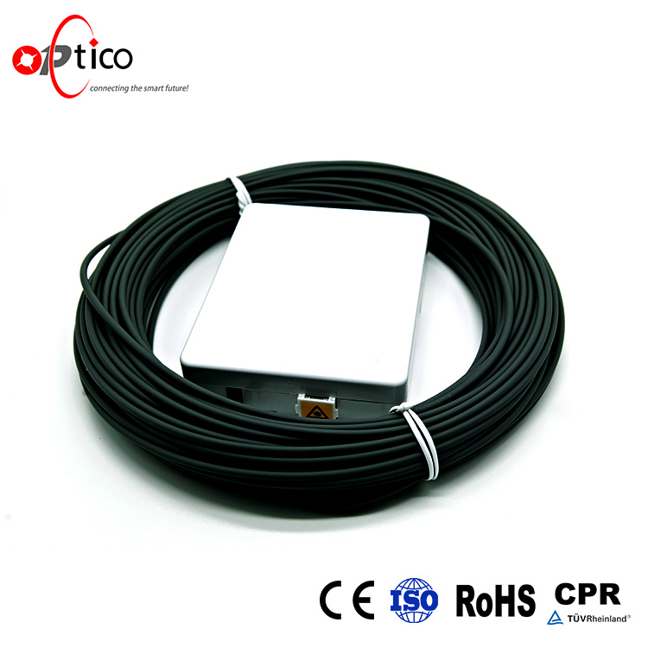

Parameters of FTTH Patch Panel:
1 Port ftth fiber optic mini patch panel terminal box
1. ABS material
2. two SC adapters
3. L86xW86xD27mm

Application of FTTH Patch Panel:
A user end product to realize optical fiber to desktop solution;
It can be used in home or working area to accomplish double-core fiber access and port output;
Used in the end termination of residential buildings and villas, to fix and splice with pigtails;
Used in FTTH indoor application, home or work area;
Provide users with optical access or data access;
Suitable for 1 pcs SC adapters;
May store surplus fiber inside, easy for operation;

Characteristics of FTTH Patch Panel:
1.reasonable inner space design
2.sutable bending radius
3.protect optical fiber
4.realize FTTD (fiber to the desktop)system
5.L86xW86xD27mm
6.Package Weight: 0.1kg (0.22lb.)
7.Package Size: 9cm x 9cm x 3cm (3.54in x 3.54in x 1.18in)

Shipping Ways of FTTH Patch Panel:


Optico Company Certificates:
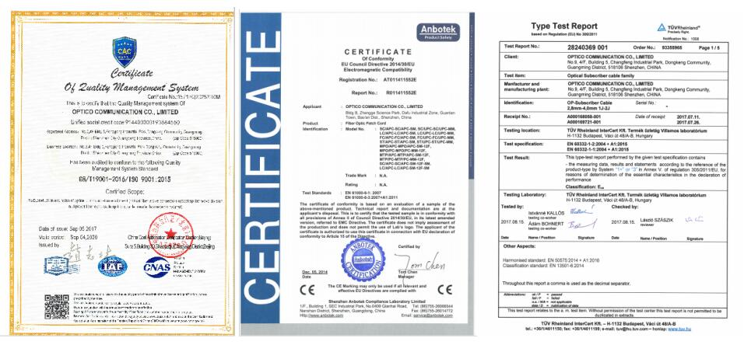

Optico Company Strength:

